Static Routing

Configuration/IP Routes for Static Routing
This document shows the results of the “#show ip route” command run in CLI for static routing topology and “ping 192.168.x.x” results.

Topology Diagram
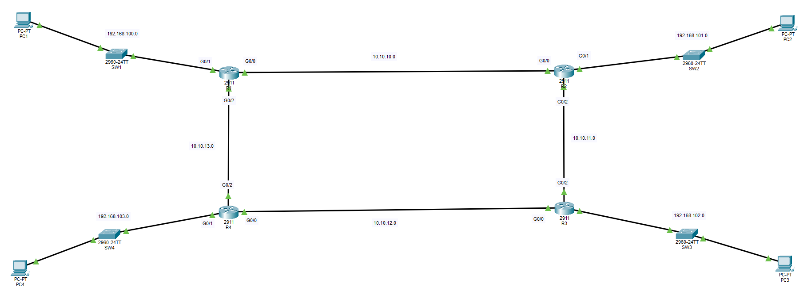

Configurations of Routers
Devices | “#show ip route” command results
R1 | 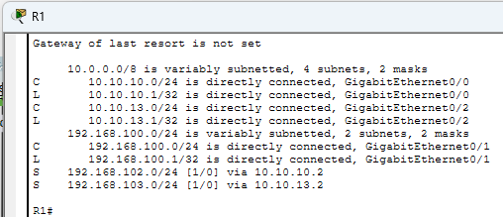
R2 | 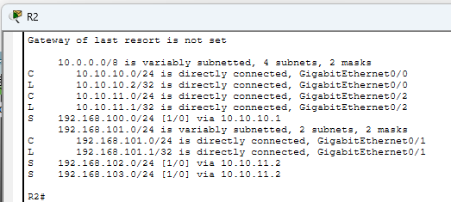
R3 | 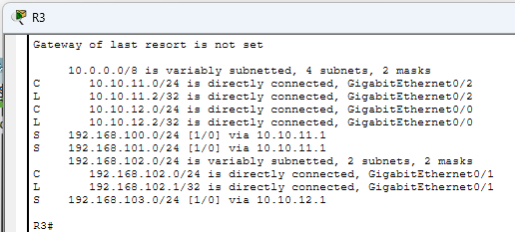
R4 | 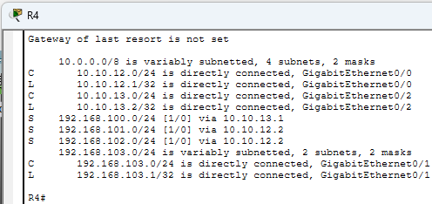

Devices | PCs ping test results
from PC1  to PC3 | 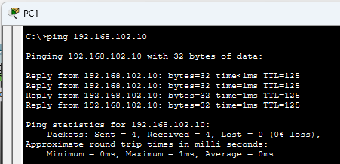
from PC2  to PC4 | 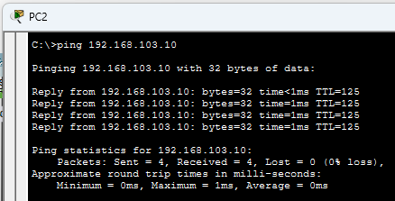
from PC3  to PC1 | 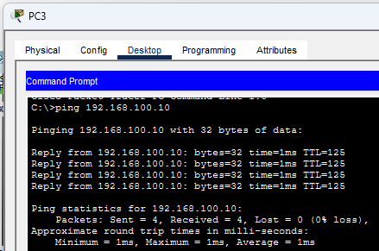
from PC4  to PC2 | 